

SOFTWARE ENGINEERING DEPARTMENT

SIR SYED UNIVERSITY OF ENGINEERING & TECHNOLOGY

PROJECT REPORT

OF

**GPA/CGPA CALCULATOR**

Course Title:

**SOFTWARE CONSTRUCTION AND DEVELOPMENT**

Batch: 2022, Semester

**Picture of our Project:**

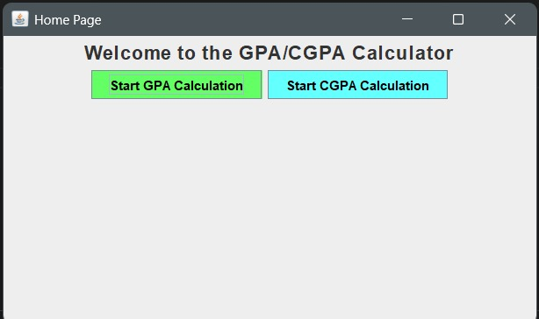

**CONTRIBUTORS:**

|  |
| --- |
| RESEARCH AND REQUIREMENT ANALYSIS |
| DEVELOPMENT AND IMPLEMENTATION |
| DOCUMENTATION AND REPORT MAINTENANCE |

**Submitted on 13-JAN-2025**

**Submitted to: ENGR. SAAD AND ENGR. PRIHA BHATTI**

**TEAM PROFILE**

1. **Tineshia D’souza (2022F-BSE-265)**
2. **Yagome Hina (2022F-BSE-305)**
3. **Syeda Asfa Naveed (2022F-BSE-354)**
4. **Ayesha Ghouri (2022F-BSE-284)**
5. **Aiza Asif (2022F-BSE-50)**

### Purpose of the CGPA Calculator Project

The CGPA Calculator project aims to simplify GPA and CGPA calculations for students and institutions. It provides an intuitive GUI for inputting grades and credits, automates accurate calculations, and supports saving and retrieving records. Key features include semester GPA and cumulative CGPA calculations, customizable grading scales, and error handling for user input. The project enhances academic tracking and lays the groundwork for future extensions like performance analysis and database integration

**CODE:**

calculator.java

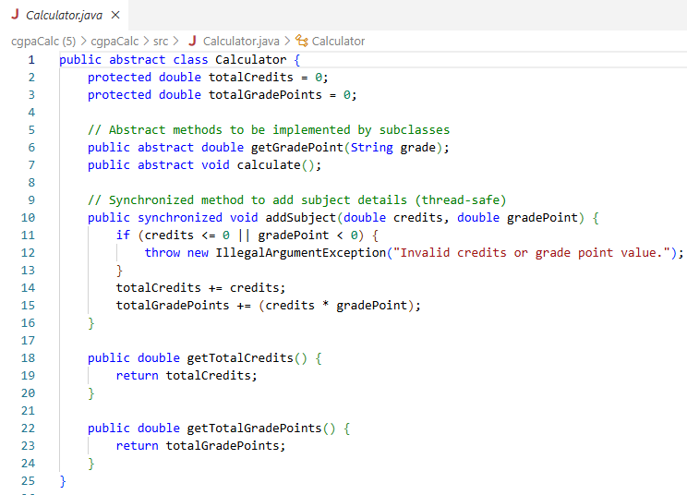

CGPACalculator.java

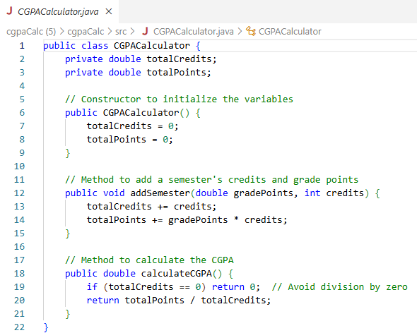

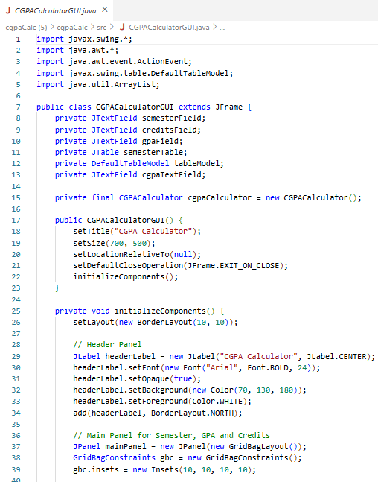CGPACalculatorGUI.java

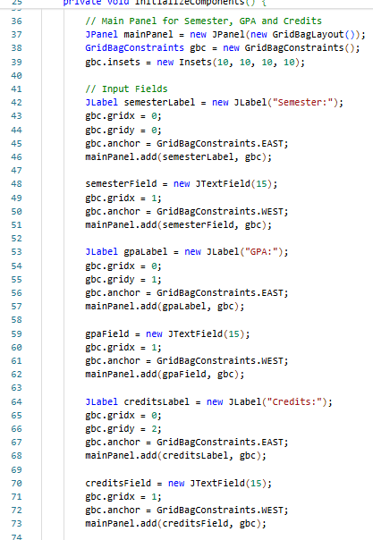

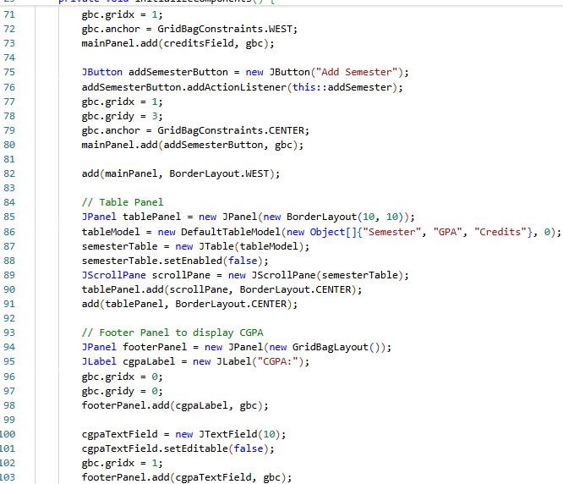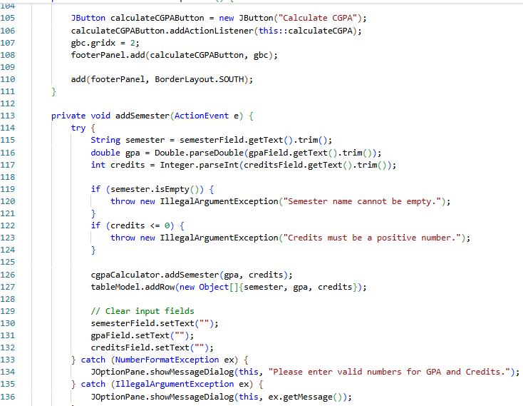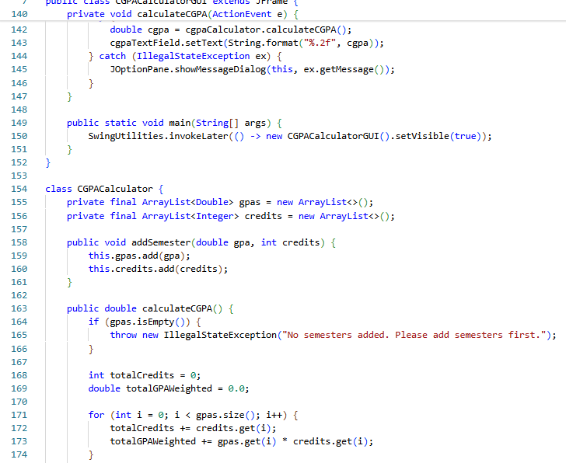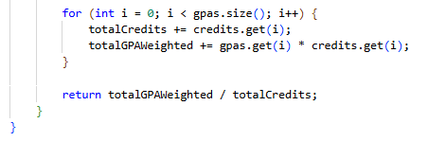

GPACalculator.java

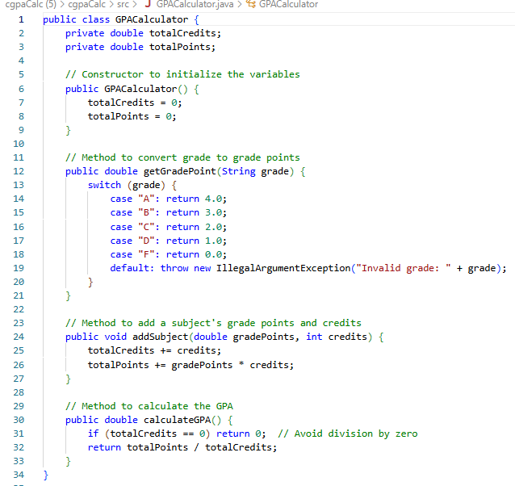

CGPACalculatorGUI.java

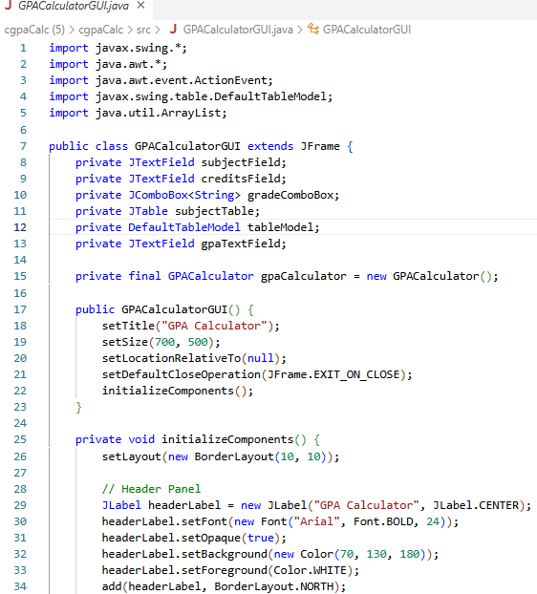

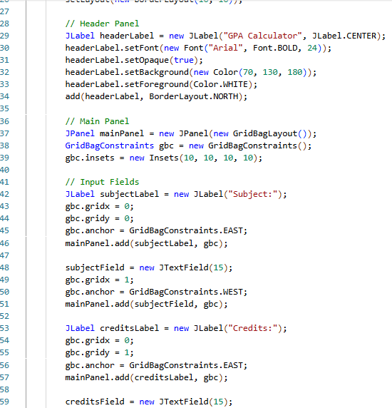

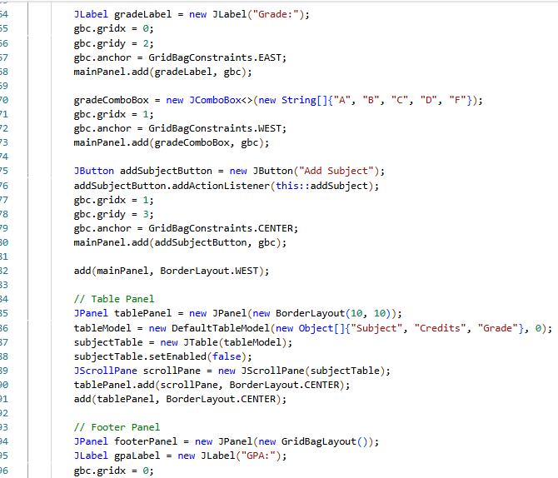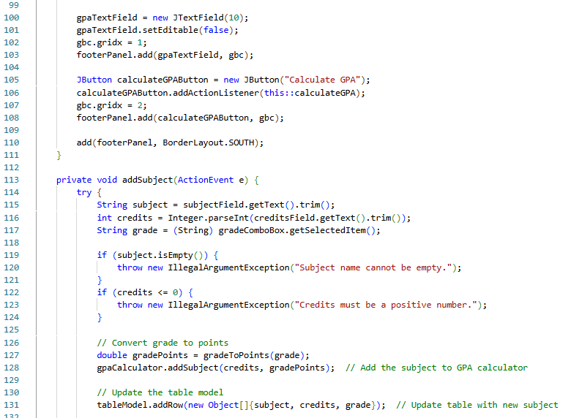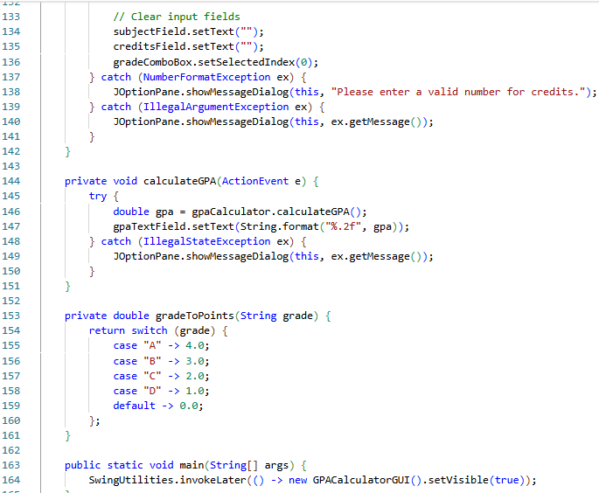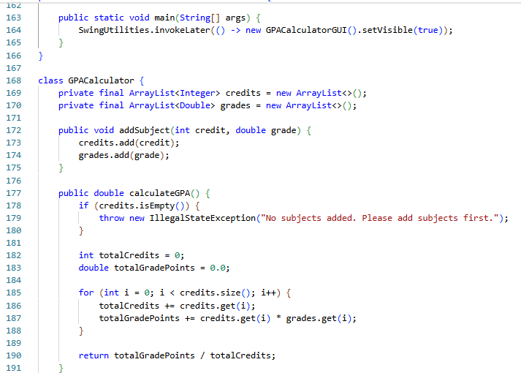

HOMEPAGE

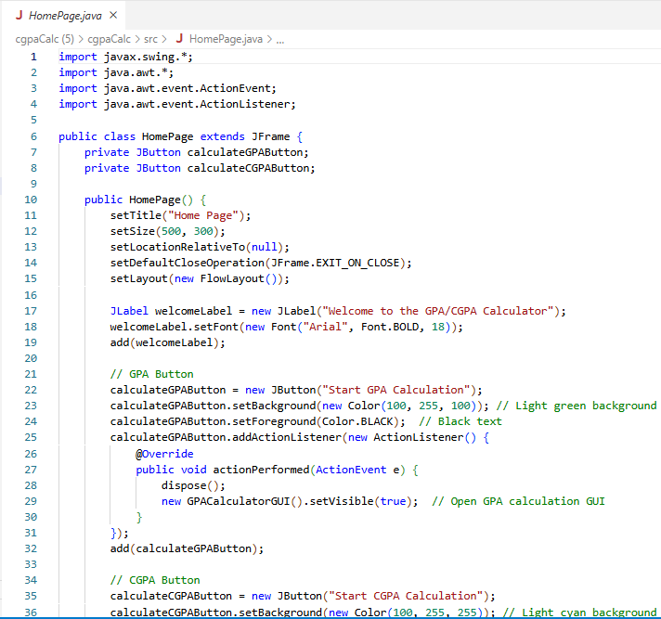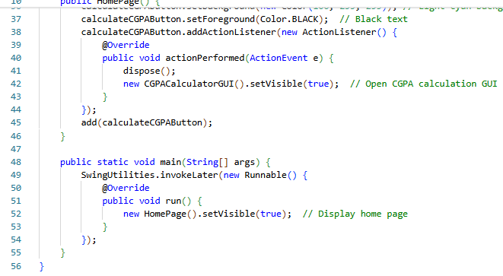

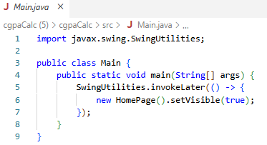MAIN JAVA

**Project Output**:

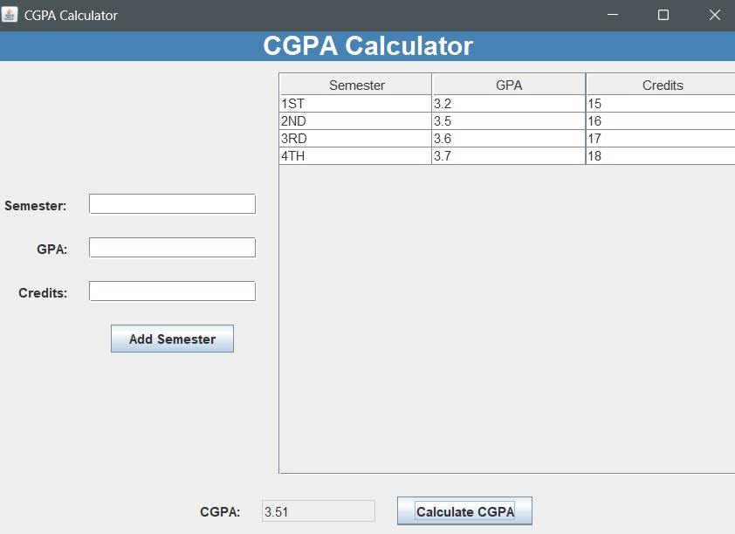

[Powered by TCPDF (www.tcpdf.org)](http://www.tcpdf.org/)